FRACTIONS OF AN AMOUNT
Pearson Edexcel – Tuesday 19 May 2020 - Paper 1 (Non-Calculator) Higher Tier
1.
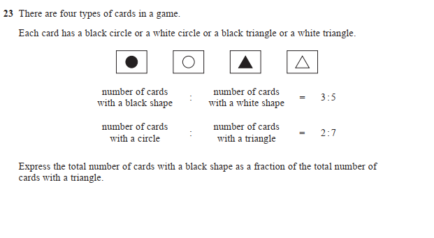
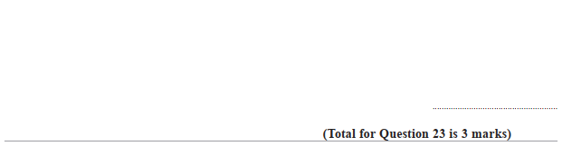

Pearson Edexcel - Tuesday 21 May 2019 - Paper 1 (Non-Calculator) Higher Tier
2.
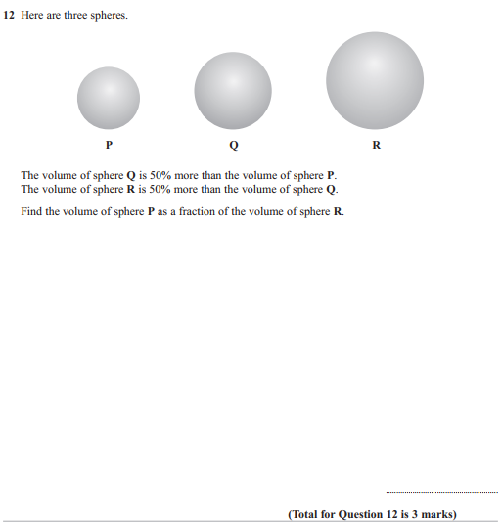
3.

